DevSecOps Tasks
DevSecOps – Two Jenkins Challenges
Challenge 1: Freestyle Project
First
Build a DevSecOpps workflow using a Jenkins Freestyle project.
Source: spring-petclinic.git
Challenge 2: Declarative Pipeline
Second
Implement the same workflow using a Declarative Jenkinsfile.
Source: spring-petclinic.git
What we will implement
A DevSecOps pipeline integrates security checks into the software build process.
1. Source Code Checkout
GitHub repository
2. Security Scanning
OWASP Dependency-Check and Trivy, where compatible
3. Build and Test
Maven clean verify
4. Reports and Results
Build status, test reports and security findings
We can also integrate SonarQube for static code analysis if your existing configuration is available. OWASP Dependency-Check checks project dependencies for known vulnerabilities.

Jenkins plugin
+1
Challenge 1 — Freestyle Project
Step 1: Verify your existing Jenkins server
Mama, before creating the job, let's check the tools installed on your existing Jenkins server. This avoids build failures caused by missing tools or incorrect configurations.
Connect to your Jenkins EC2 instance using SSH or your existing terminal.
Run these commands one by one:

java -version
mvn -version
git --version
docker --version
trivy --version
Some commands might report that the tool is not installed. That's okay for now; don't install anything yet.
Next, open Jenkins in your browser.
- Go to Manage Jenkins → Plugins → Installed plugins.
- Check whether these plugins are installed:
  - Git plugin
  - Maven Integration plugin (optional for our shell-based build)
  - Pipeline plugin
  - OWASP Dependency-Check plugin
  - SonarQube Scanner plugin, if using SonarQube
The Jenkins Pipeline plugin is relevant to our second challenge, and Dependency-Check has a Jenkins integration for running analyses and publishing reports
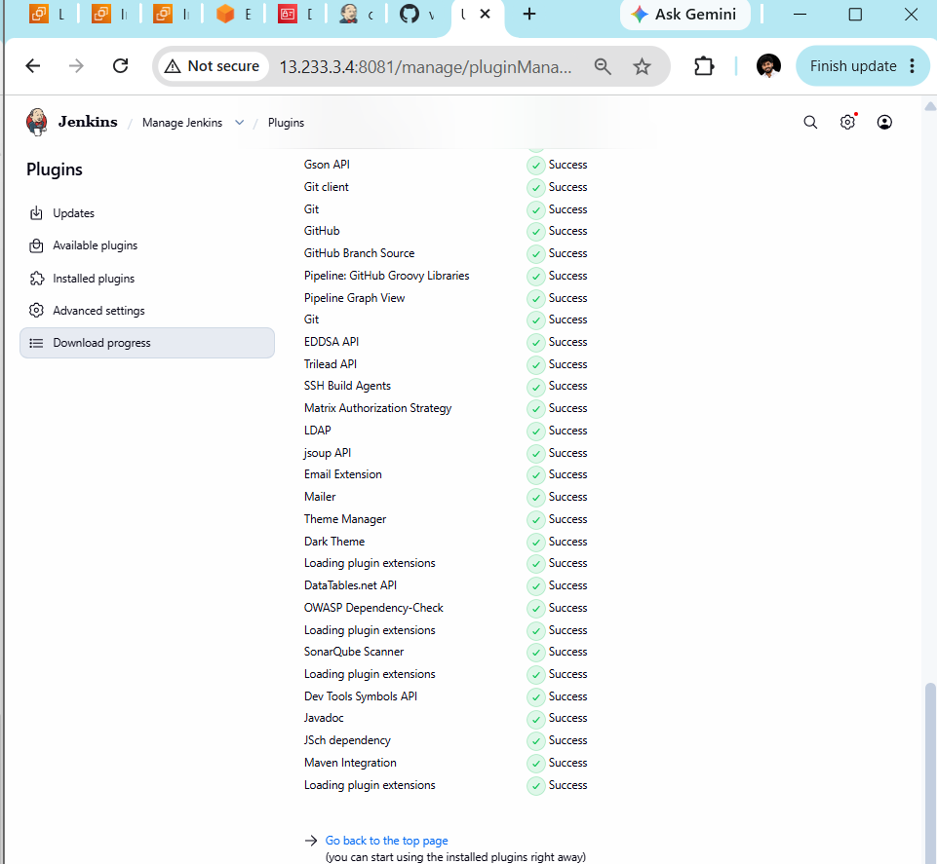
Step 2: Configure OWASP Dependency-Check
2.1 Open Jenkins system configuration
- Go to your Jenkins dashboard.
- Click Manage Jenkins.
- Open Tools (sometimes shown as Global Tool Configuration in older Jenkins versions).
- Find the Dependency-Check section.
2.2 Configure the tool
If the section is available:
- Click Add Dependency-Check.
- Name: Dependency-Check
- Enable Install automatically, if available.
- Select the available version.
- Click Save.
If you do not see a Dependency-Check section, don't worry. The plugin may need a different configuration path or may be installed without its command-line tool configured.
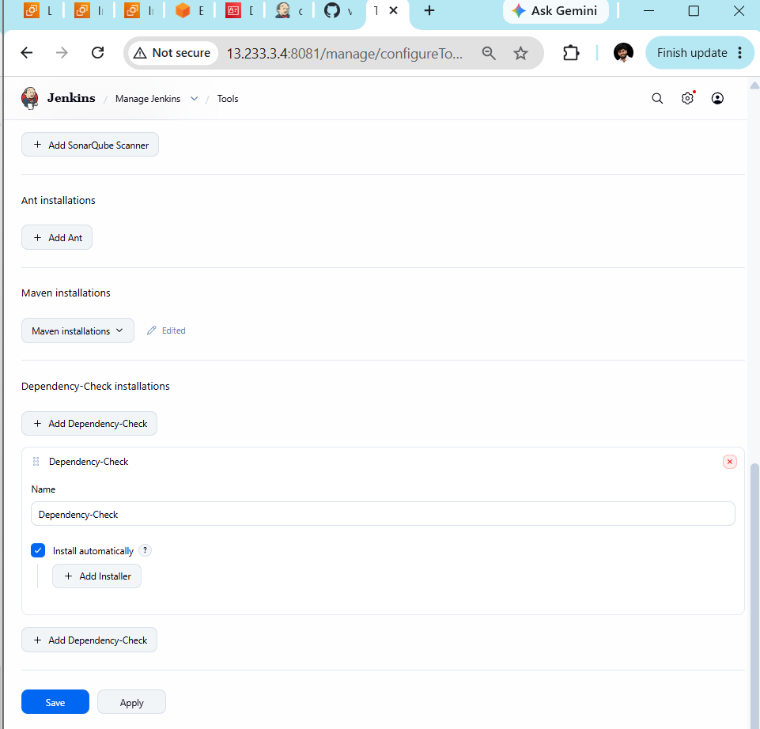
Step 2.3: Save the configuration
- Click Save at the bottom of the Tools page.
- Wait for Jenkins to return to the dashboard.
Step 3: Create the Freestyle project
3.1 — Open New Item
- Click New Item on the Jenkins dashboard.
- Enter this name:
devsecops-freestyle-petclinic
- Select Freestyle project.
- Click OK.
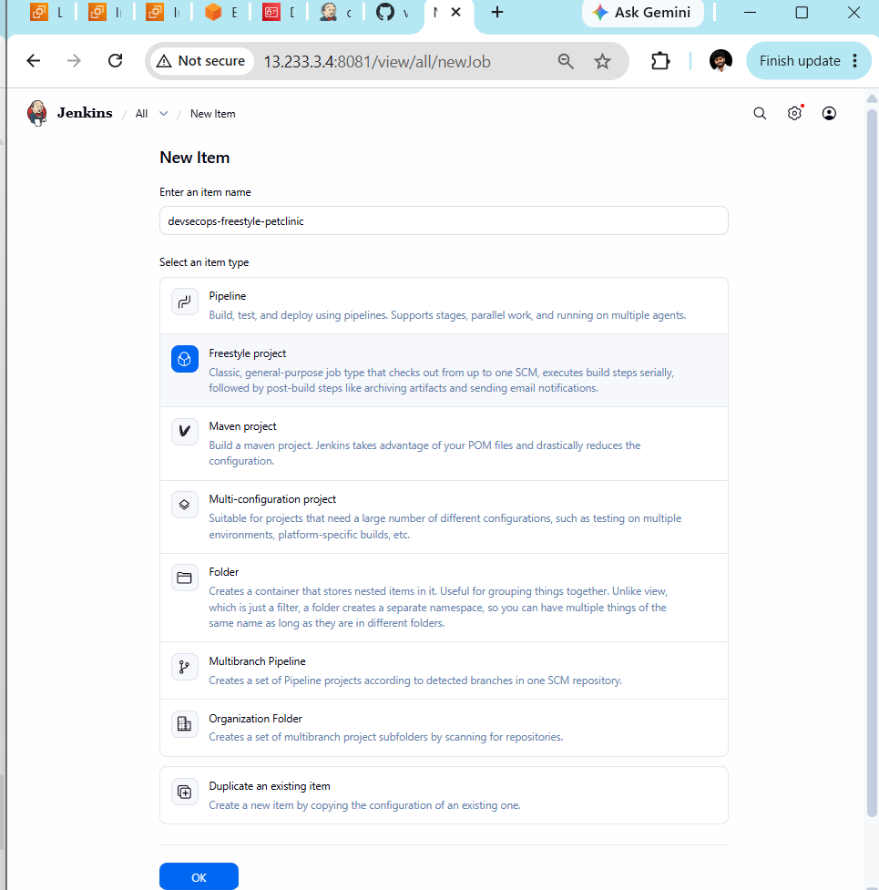
Step 4: Configure Source Code Management
On the job configuration page:
- Scroll to Source Code Management.
- Select Git.
- In Repository URL, enter:
https://github.com/betawins/spring-petclinic.git
Copy URL
- Leave Credentials as - none - because this is a public repository.
- For Branch Specifier, keep */main if the repository uses main. If checkout later fails, we'll verify the default branch.
- Do not click Build Now yet.
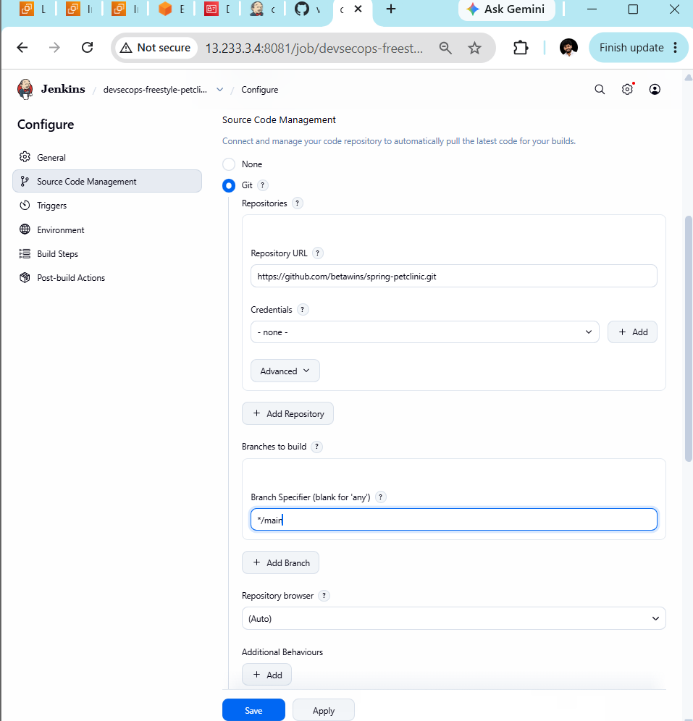

Step 5: Configure the build
- Click Save at the bottom.
- Open your devsecops-freestyle-petclinic job.
- Click Configure.
- Scroll down to Build Steps.
- Click Add build step → Execute shell.
Paste this script into the command box:

set -eu

echo "===== Java Version ====="
java -version

echo "===== Maven Version ====="
mvn -version

echo "===== Workspace Files ====="
ls -la

echo "===== Build and Test Spring PetClinic ====="
mvn clean verify
This will verify the Java and Maven versions and build/test the application.
Important: This is our initial build step. We'll add the OWASP dependency vulnerability scan after verifying that the application builds successfully.
Click Save after adding the script, then click Build Now.
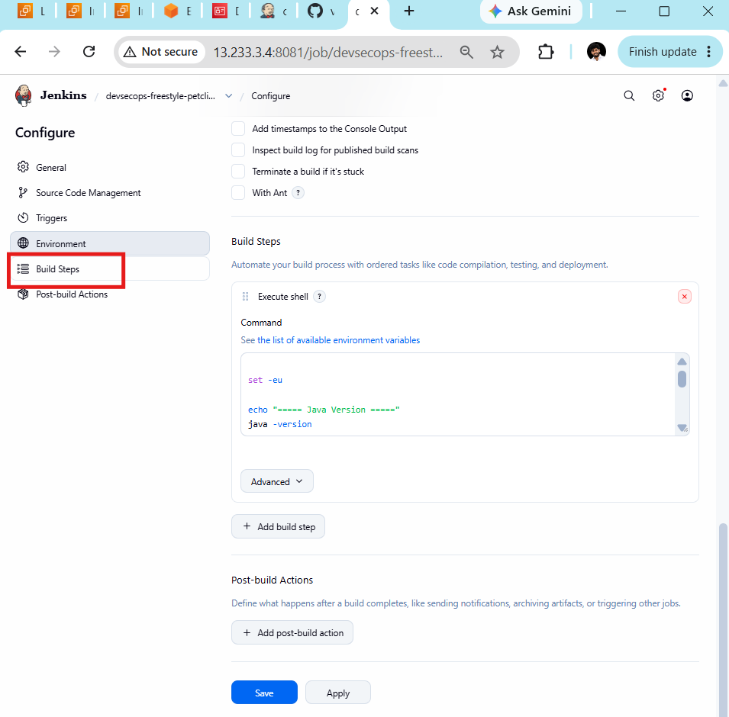
Step 6: Configure the build
- Click Save at the bottom.
- Open your devsecops-freestyle-petclinic job.
- Click Configure.
- Scroll down to Build Steps.
- Click Add build step → Execute shell.
Paste this script into the command box:

set -eu

echo "===== Java Version ====="
java -version

echo "===== Maven Version ====="
mvn -version

echo "===== Workspace Files ====="
ls -la

echo "===== Build and Test Spring PetClinic ====="
mvn clean verify
This will verify the Java and Maven versions and build/test the application.
Important: This is our initial build step. We'll add the OWASP dependency vulnerability scan after verifying that the application builds successfully.
Click Save after adding the script, then click Build Now.

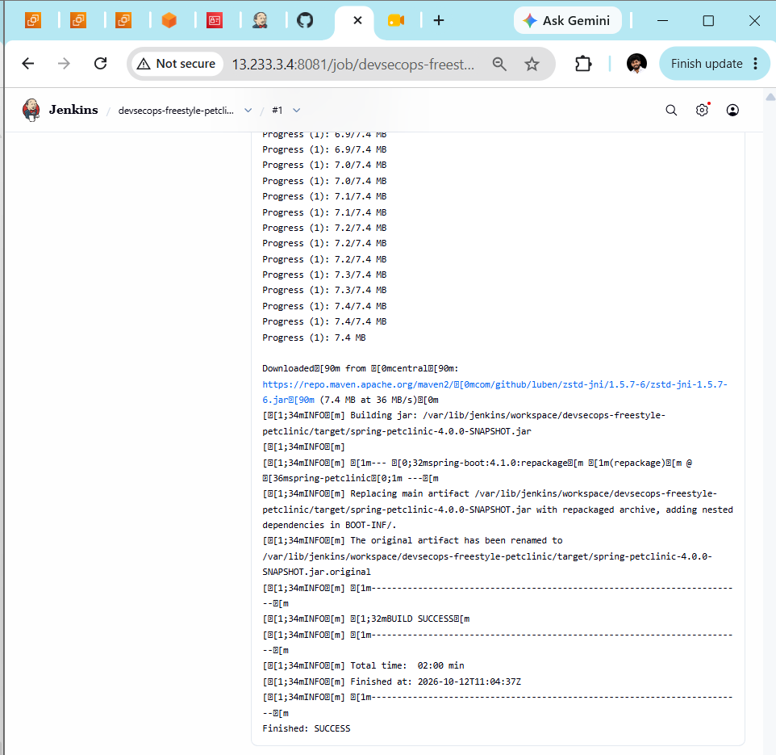
Step 7— Add OWASP Dependency-Check scanning
Step 7.1 - Add the Dependency-Check build step
- Open Jenkins and navigate to devsecops-freestyle-petclinic.
- Click Configure.
- Scroll down to Build Steps.
- Keep your existing Execute shell step unchanged.
- Click Add build step → Invoke Dependency-Check.
A new Dependency-Check configuration section should appear below the Maven build step.
Step 7.2 — Configure the scan
Look for fields similar to these. The exact fields depend on your installed plugin version.
Field | What to configure
Dependency-Check installation | Select Dependency-Check if offered
Arguments | --scan . --format HTML --out dependency-check-report
Additional properties | Leave blank unless required
The arguments tell OWASP Dependency-Check to scan the checked-out project and generate an HTML report.
Important: Don't enter these arguments until you confirm the field names shown by your plugin. Some Jenkins plugin versions provide a separate arguments field; others configure the installation differently.
Step 7.3 — Save the configuration
- Scroll to the bottom.
- Click Save.
- Return to the devsecops-freestyle-petclinic job.
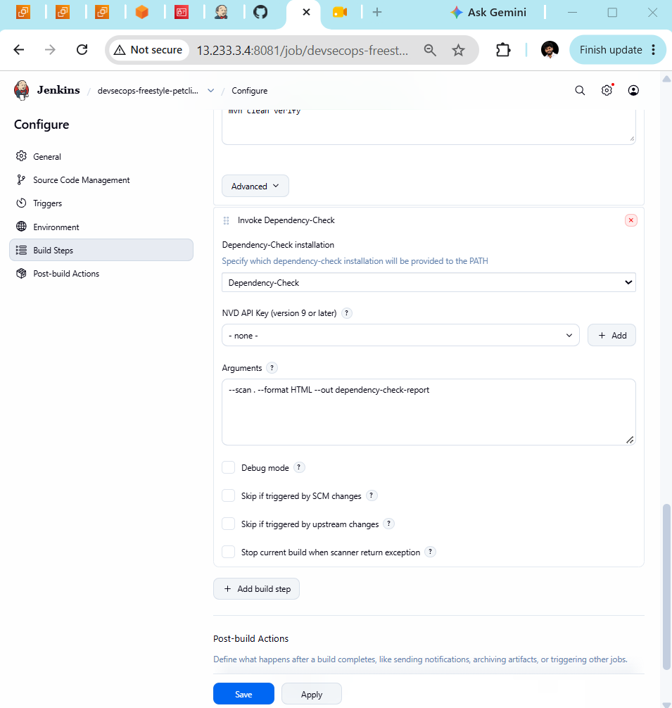
Step 7.4 — Run the security scan
- Click Build Now.
- Open the latest build number.
- Click Console Output.
- Look for Dependency-Check starting and completing its analysis.
The first scan may take longer because the vulnerability database needs to be downloaded or updated. Network access and NVD API configuration can affect the scan duration.
Step 7.5 — Verify the report
After the scan succeeds, look for the generated HTML report in the workspace or the configured output directory. We can then configure Jenkins to publish or archive the report so it is accessible from the job.
A successful scan means the analysis completed; it does not automatically mean the application has no vulnerabilities.

Step 8 — Obtain an NVD API key
OWASP Dependency-Check uses the National Vulnerability Database (NVD) to retrieve vulnerability information.
- Open the official NVD API key page: Request an NVD API Key.
- Complete the request form using your email address.
- Check your email for the API key.
Keep the key private. Don't paste it into this chat or hard-code it in your Jenkins build script.
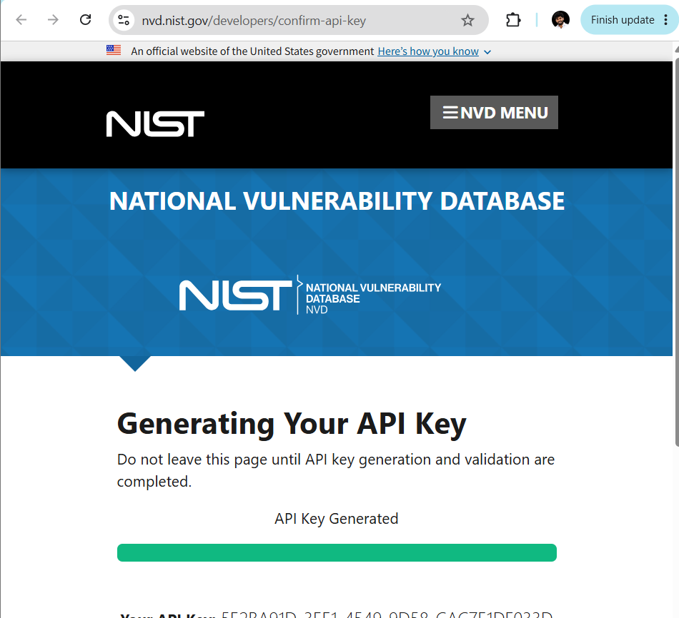
Step 9 — Add the key to Jenkins
Open Manage Jenkins → Credentials.
- Select the appropriate credentials store and domain, typically System → Global credentials (unrestricted).
- Click Add Credentials.
- Select Secret text as the Kind.
- Paste your NVD API key into Secret.
- Enter an ID such as nvd-api-key.
- Click Create.
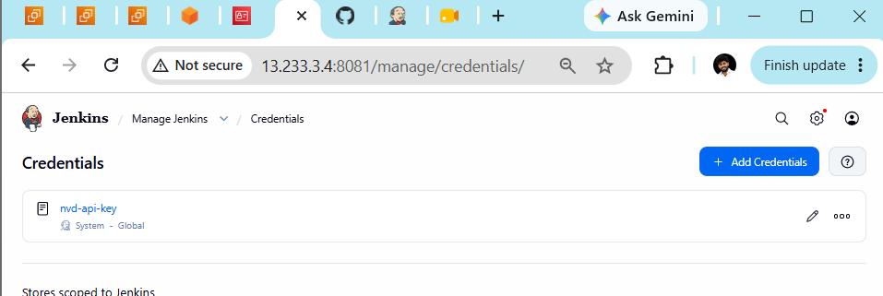
Step 10 — Configure the Dependency-Check build step
- Open devsecops-freestyle-petclinic.
- Click Configure.
- Scroll to Build Steps → Invoke Dependency-Check.
- Find NVD API Key.
- Click Add beside that field and select the credential you created, if the dropdown supports credentials.
- Keep these settings:

Setting | Value
Dependency-Check installation | Dependency-Check
Arguments | --scan . --format HTML --out dependency-check-report
Debug mode | Unchecked
- Click Save.
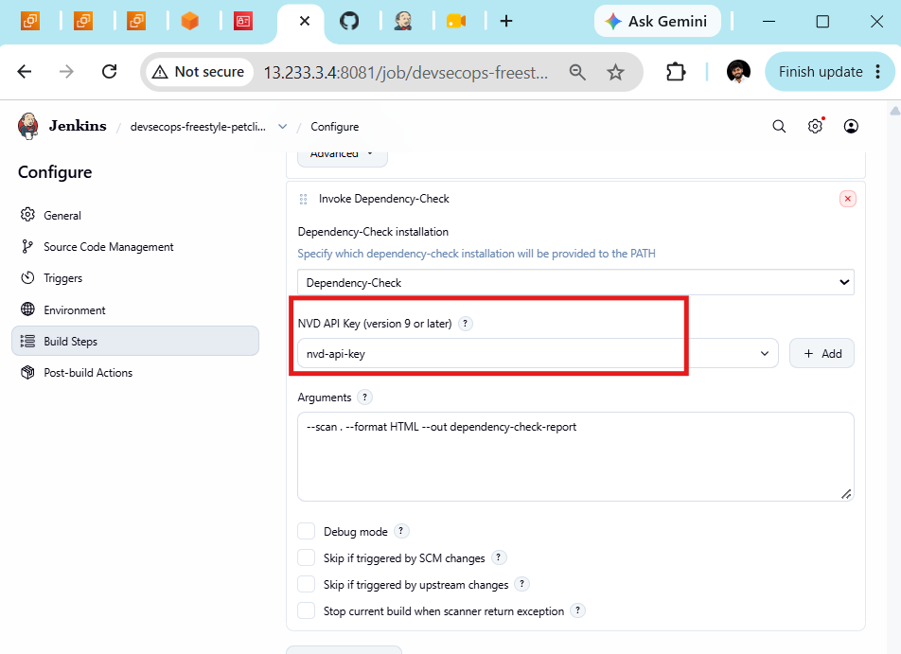
Step 11 — Run the build again
Click Build Now, then open the latest Console Output.
The first successful database update can take several minutes. If the build succeeds, we will verify the HTML report and complete Challenge 1.
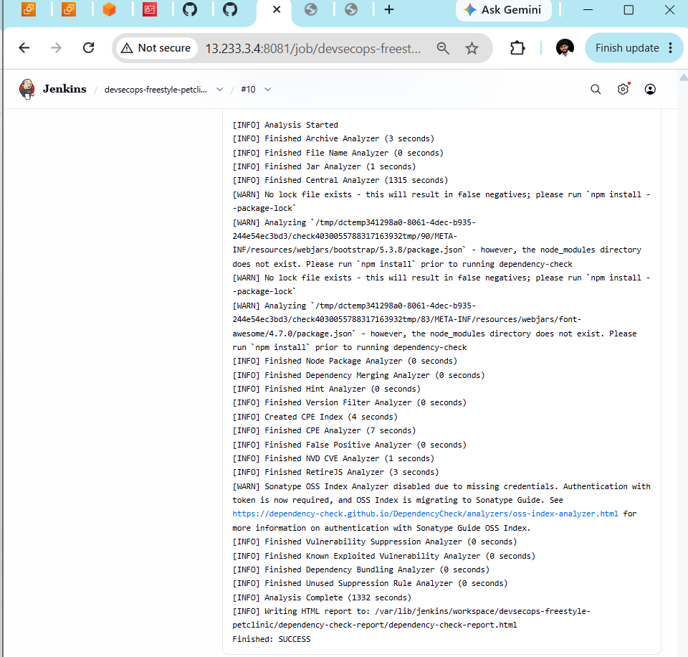

Step 12 — Open the Dependency-Check HTML report
The console confirms the report was written to:
/var/lib/jenkins/workspace/devsecops-freestyle-petclinic/dependency-check-report/dependency-check-report.html
- Open Jenkins and select devsecops-freestyle-petclinic.
- Click Workspace.
- Open the dependency-check-report directory.
- Click dependency-check-report.html, if Jenkins provides a link to open it.
If the HTML file isn't clickable in Workspace, that's okay—we can configure Jenkins to publish it as a build artifact.
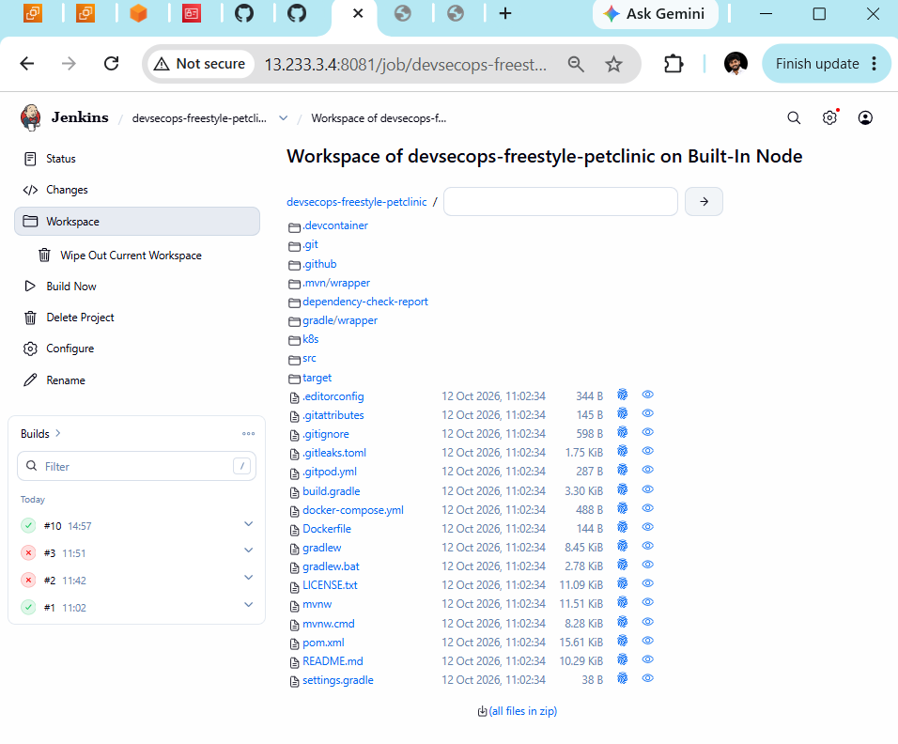

Step 13 — Verify the HTML report
- In the screen you're currently viewing, click the dependency-check-report folder.
- Check whether dependency-check-report.html appears inside it.
- Send me a screenshot of the folder contents.
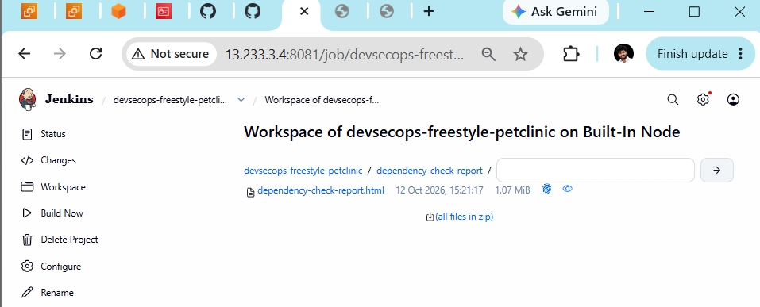
Step 14 — Configure HTML report publishing
- Click Configure in the left menu.
- Scroll down to Post-build Actions.
- Click Add post-build action.
- Check whether you see Publish HTML reports.
Step 15 — Configure the XML Report Pattern
In your screenshot, the XML Report Pattern field is empty. The Dependency-Check publisher expects an XML report, but your current scan generated an HTML report only.
Let's fix this carefully.
- In the XML Report Pattern field, enter:
dependency-check-report/dependency-check-report.xml
- Don't click Save yet. We need to ensure the scan actually generates this XML file first.
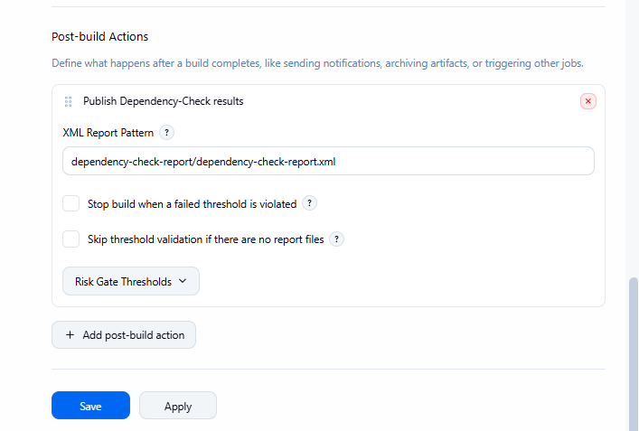
Step 16 — Update the Dependency-Check arguments
Scroll up to your Invoke Dependency-Check build step and change the Arguments field to:
--scan . --format HTML --format XML --out dependency-check-report
This requests both HTML and XML reports.
Then click Save and run Build Now. The next build should generate both report formats. After it completes, we'll confirm that the XML file exists and check whether Jenkins publishes the results.
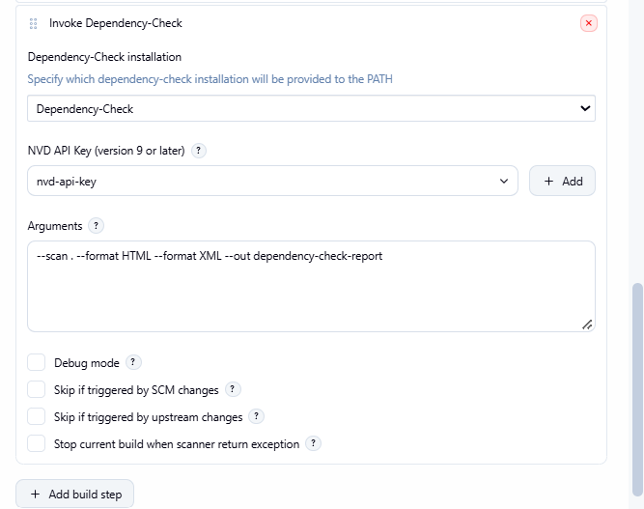
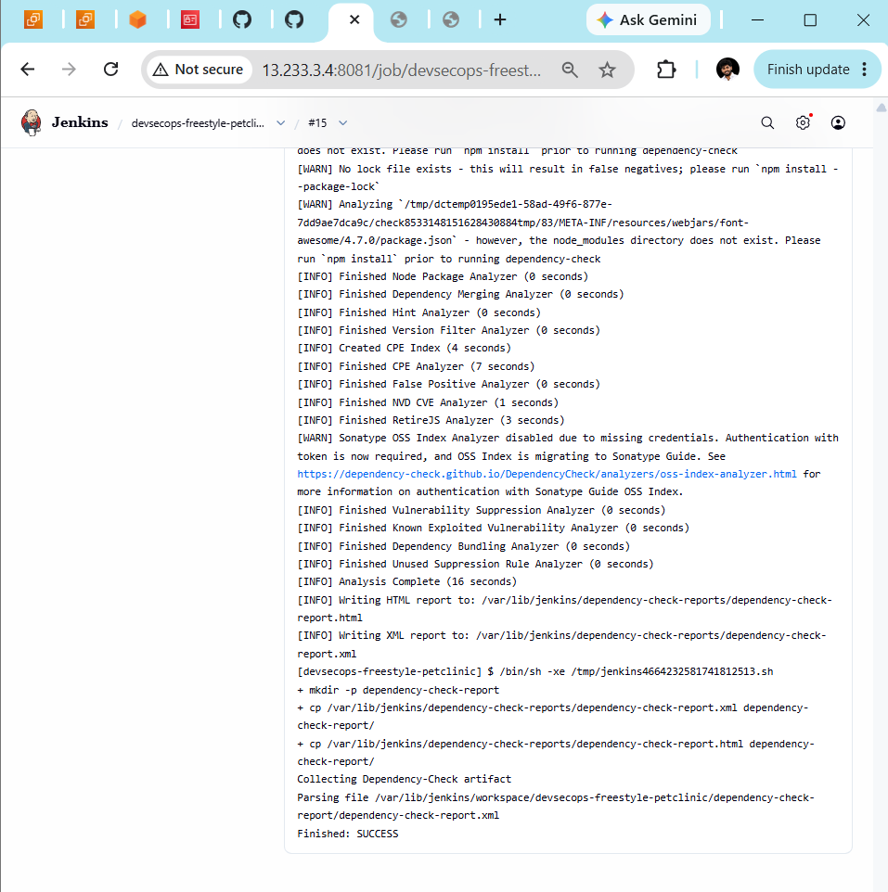

Step 17 : View the security report
- Open the devsecops-freestyle-petclinic job.
- Look for the Dependency-Check report link or report section.
- Open it and check the vulnerability findings, including severity levels such as Critical, High, Medium, and Low.
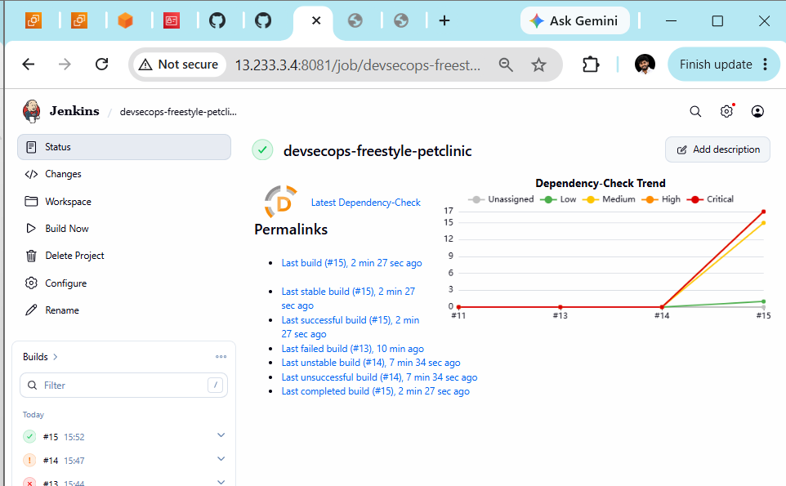
Step 18 : Open the detailed report
- Click Latest Dependency-Check near the top of the page.
- Review the vulnerability summary and affected dependencies.
- Send me a screenshot of the report.
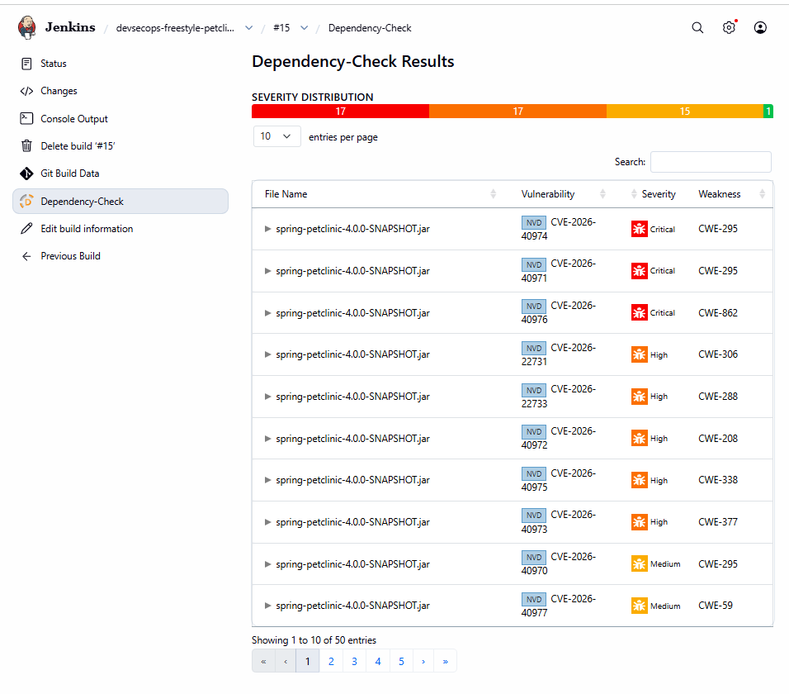
Step 19 — Review Critical vulnerabilities
Your current Jenkins job is devsecops-freestyle-petclinic, and Build #15 successfully generated and published the Dependency-Check report.
Step 19.1 — Identify the affected dependency
- Open Jenkins → devsecops-freestyle-petclinic.
- Open Build #15 → Dependency-Check.
- Expand the first Critical finding.
- Note the dependency name, installed version, and recommended fixed version if listed.
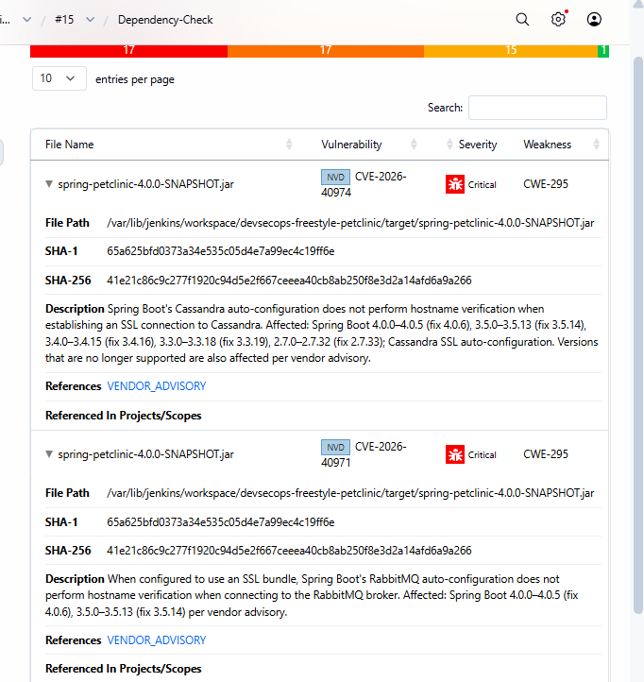
Step 19.2 — What your report shows
CVE | Component affected | Issue
CVE-2026-40974 | Cassandra auto-configuration | SSL hostname verification may not occur when connecting to Cassandra
CVE-2026-40971 | RabbitMQ auto-configuration | SSL hostname verification may not occur when connecting to RabbitMQ
The report lists affected Spring Boot versions, but it does not show the exact vulnerable dependency version in this screenshot.
Step 19.3 — Find the installed Spring Boot version
Let's inspect the project before modifying anything.
- Open your EC2 terminal or connect to the Jenkins server.
- Run:
cd /var/lib/jenkins/workspace/devsecops-freestyle-petclinic
grep -n -E 'spring-boot.version|spring-boot-starter-parent|<version>' pom.xml | head -30
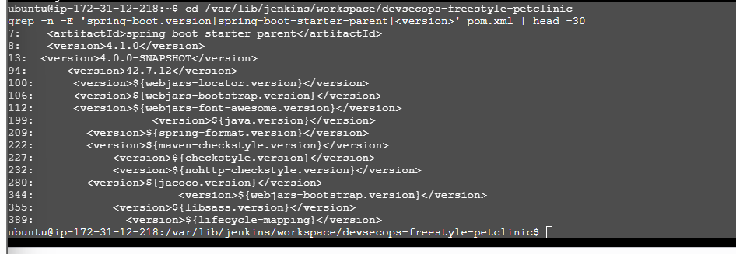
Step 19.4 — Verify the resolved Spring Boot dependencies
Before upgrading anything, let's check which Spring Boot version Maven actually resolves and whether the Cassandra and RabbitMQ auto-configuration modules are included.
Run these commands from your current project directory:
mvn dependency:tree -Dincludes=org.springframework.boot
Then run:
mvn help:evaluate -Dexpression=project.parent.version -q -DforceStdout
The second command should print the parent version resolved by Maven.
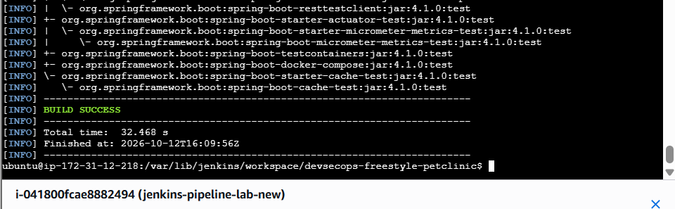
Step 19.5 — Check the specific affected modules
Run this command from your current project directory:
mvn dependency:tree -Dincludes=org.springframework.boot:spring-boot-cassandra,org.springframework.boot:spring-boot-rabbitmq
If it doesn't show either module, that alone doesn't prove the findings are false—the scanner may be detecting metadata or components through other dependencies.
Then run:
mvn help:evaluate -Dexpression=project.parent.version -q -DforceStdout
This should print the Spring Boot parent version.
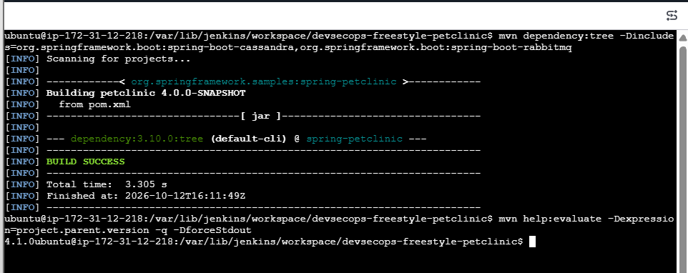
Step 19.6 — Verify the Dependency-Check findings
Your latest results confirm:
- Spring Boot parent version: 4.1.0
- Maven dependency-tree command: BUILD SUCCESS
- The specific Cassandra and RabbitMQ module query returned no matching dependencies.
- Dependency-Check reported 50 findings, including Critical and High findings.
The module query alone doesn't prove the findings are false positives. Let's inspect the Maven dependencies and the scanner's evidence before deciding on remediation.
Run this command
In your existing Ubuntu terminal, run:
cd /var/lib/jenkins/workspace/devsecops-freestyle-petclinic

mvn dependency:tree -Dverbose > /tmp/petclinic-dependency-tree.txt

grep -Ei 'spring-boot|cassandra|rabbitmq|amqp' /tmp/petclinic-dependency-tree.txt | head -60
What to do next
- Wait for the command to finish.
- Copy the output and send it to me.
- We'll identify which Spring Boot modules and versions are actually resolved and decide the next remediation step.
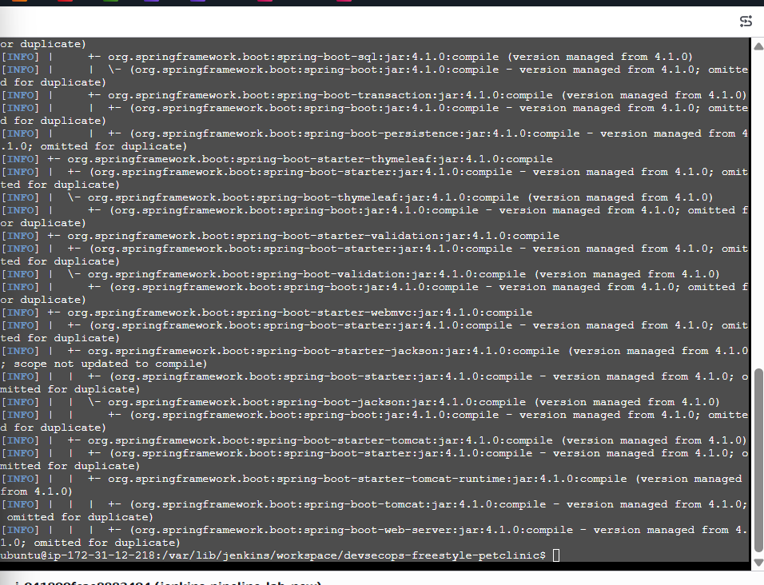

Step 19.7 — Check for the affected modules
Run these commands in your current terminal:
grep -Ei 'cassandra|rabbitmq|amqp' /tmp/petclinic-dependency-tree.txt
Then:
grep -Ei 'spring-boot.*(cassandra|rabbitmq|amqp)' /tmp/petclinic-dependency-tree.txt
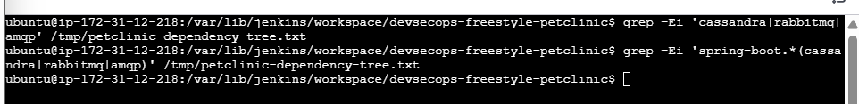
Step 19.8 — Verify the report's component identification
Run this command in your current Ubuntu terminal:
grep -n -B 5 -A 12 -E 'CVE-2026-40974|CVE-2026-40971' \
/var/lib/jenkins/dependency-check-reports/dependency-check-report.xml | head -100
This will show the XML report entries around both CVEs, including the component information Dependency-Check recorded.
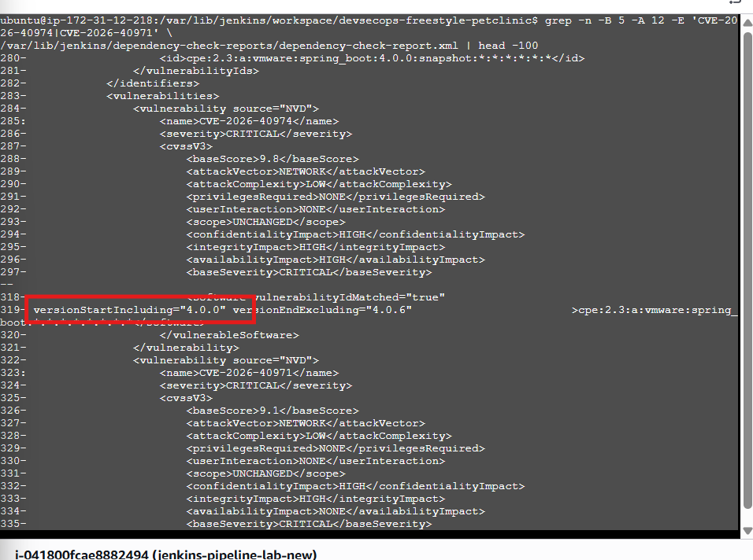
Step 19.9 — Understand the finding
Your XML contains this component identifier:
cpe:2.3:a:vmware:spring_boot:4.0.0:snapshot
But your Maven parent version is Spring Boot 4.1.0.
The report has matched the built application artifact version (4.0.0-SNAPSHOT) to a Spring Boot product identifier. That suggests a possible component-identification false positive, rather than proof that the vulnerable Cassandra or RabbitMQ modules are present.
However, we should verify the actual evidence before dismissing these Critical findings.
Step 19.10 — Check the XML evidence
Run this command:
sed -n '250,380p' /var/lib/jenkins/dependency-check-reports/dependency-check-report.xml
This will show the surrounding XML, including the component identifiers and the vulnerability records for the two CVEs.
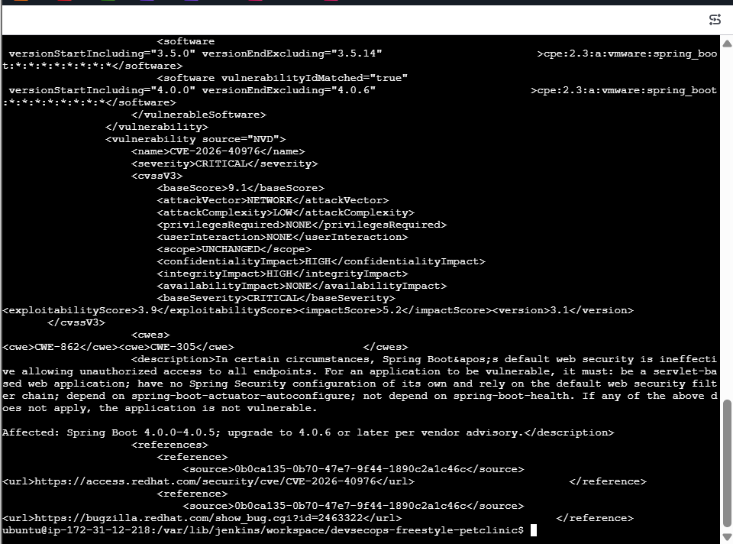
Step 19.11 — Verify the Spring Boot security advisory
The report lists these vendor advisories:
- CVE-2026-40974 — Cassandra SSL hostname verification
- CVE-2026-40971 — RabbitMQ SSL hostname verification
According to the XML, these findings affect Spring Boot 4.0.0 through 4.0.5, with a fix in 4.0.6. Your project declares 4.1.0, so the reported version match needs further verification.
Step 19.12 — Retry without extracting
Step 1: Copy and run this command:
cd /var/lib/jenkins/workspace/devsecops-freestyle-petclinic

unzip -p target/spring-petclinic-4.0.0-SNAPSHOT.jar META-INF/MANIFEST.MF
But since unzip is not installed, use this alternative instead:
python3 -c "import zipfile; z=zipfile.ZipFile('target/spring-petclinic-4.0.0-SNAPSHOT.jar'); pri
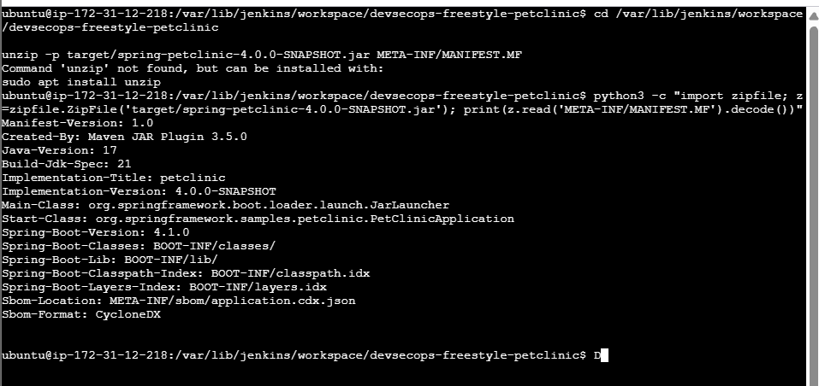
Step 19.13 — Verify the actual Spring Boot dependencies
Your output confirms:
Property | Actual value
Spring Boot version | 4.1.0
Application version | 4.0.0-SNAPSHOT
Main application class | org.springframework.samples.petclinic.PetClinicApplication
Packaging | Spring Boot executable JAR
Important finding: The Dependency-Check report appears to associate the application's version 4.0.0-SNAPSHOT with a Spring Boot CPE. But the packaged JAR confirms Spring Boot 4.1.0. This is evidence of a possible false-positive identification, not final proof.
Let's check whether the vulnerable Cassandra or RabbitMQ modules are actually packaged in the application.
Step 1: Run this command:
cd /var/lib/jenkins/workspace/devsecops-freestyle-petclinic

python3 -c "import zipfile; z=zipfile.ZipFile('target/spring-petclinic-4.0.0-SNAPSHOT.jar'); p
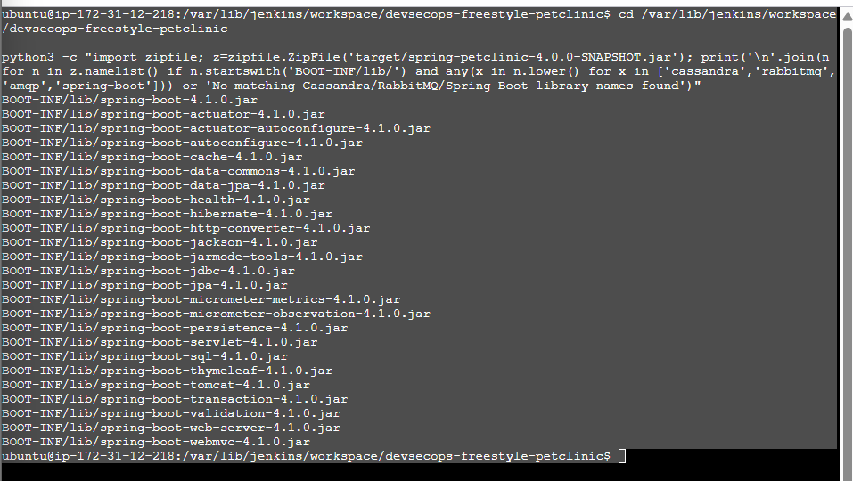
Step 19.14 — Verify the CVE IDs in the XML report
Run this command:
grep -n -B 5 -A 8 -E 'CVE-2026-40974|CVE-2026-40971|CVE-2026-40976' \
/var/lib/jenkins/dependency-check-reports/dependency-check-report.xml | head -100
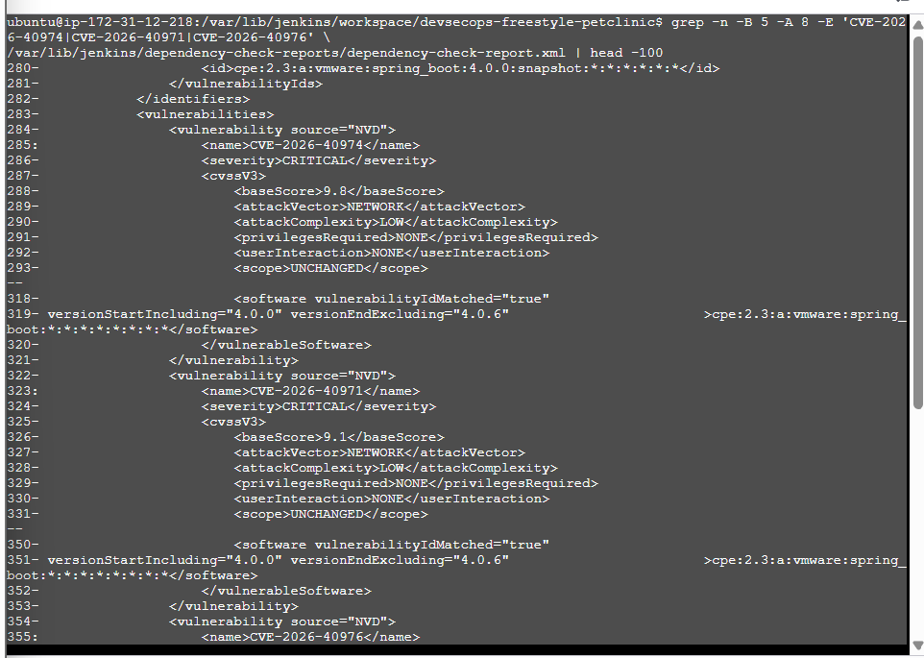

Step 19.15 — Identify the affected component
Run this command exactly:
grep -n -B 35 'CVE-2026-40974' \
/var/lib/jenkins/dependency-check-reports/dependency-check-report.xml \
| head -40
Then run:
sed -n '245,285p' \
/var/lib/jenkins/dependency-check-reports/dependency-check-report.xml
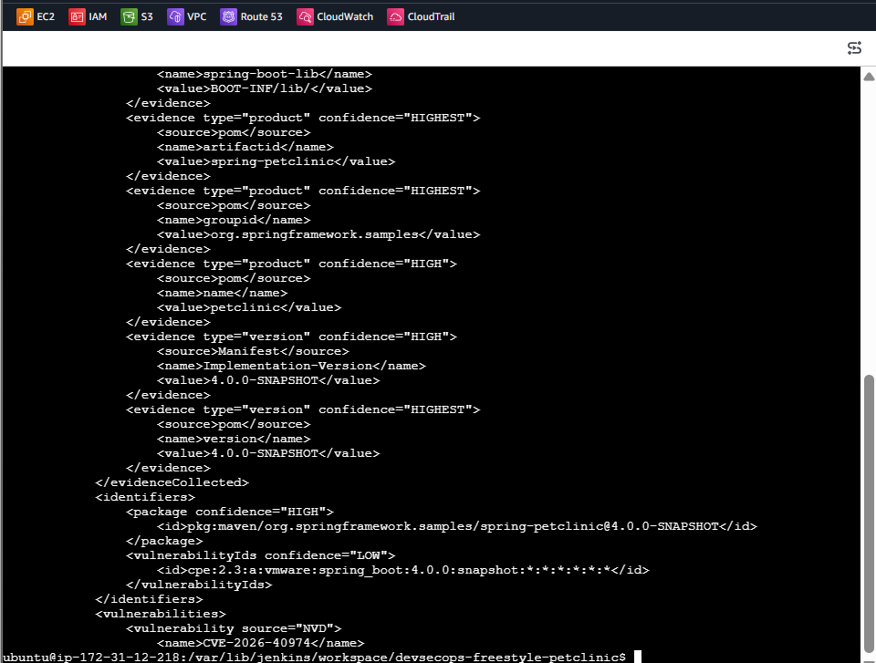
Findings confirmed
Your XML report shows:
Field | Value
Application artifact | spring-petclinic
Application version | 4.0.0-SNAPSHOT
Spring Boot version in packaged JAR | 4.1.0
Matched CPE | vmware:spring_boot:4.0.0:snapshot
CPE match confidence | LOW
What does this mean?
Dependency-Check appears to have matched the application's version (4.0.0-SNAPSHOT) to a Spring Boot CPE, even though the actual Spring Boot libraries are version 4.1.0.
This is strong evidence of a possible false positive for these findings. However, we should verify the remaining CVE conditions before closing the investigation.
Step 19.16 — Check the Dependency-Check report for the matched component
Run this command, mama:
grep -n -B 10 -A 20 'CVE-2026-40976' \
/var/lib/jenkins/dependency-check-reports/dependency-check-report.xml
Then run:
grep -n -A 12 -B 5 'CVE-2026-40976' \
/var/lib/jenkins/dependency-check-reports/dependency-check-report.html | head -50
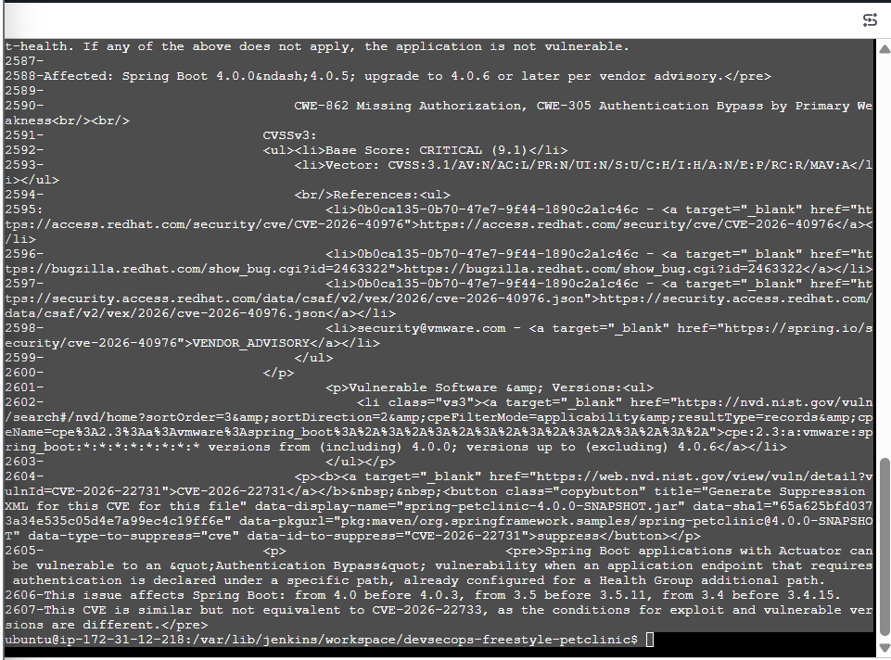
report shows:
- The three CVEs are associated with the application artifact spring-petclinic-4.0.0-SNAPSHOT.jar.
- The matched Spring Boot CPE has LOW confidence.
- The report says CVE-2026-40976 affects Spring Boot versions 4.0.0 through versions before 4.0.6.
- Your packaged application uses Spring Boot 4.1.0.
- Your JAR contains spring-boot-health-4.1.0.jar. The report's own description says applications that depend on spring-boot-health are not vulnerable to CVE-2026-40976.
These findings strongly suggest that the reported CVEs may be false positives caused by incorrect CPE identification. We should still validate the other two CVEs against the official advisories before closing the investigation.
Step 19.17 — Verify the Spring Boot version in the dependency tree
Run this command:
cd /var/lib/jenkins/workspace/devsecops-freestyle-petclinic

mvn dependency:tree -Dincludes=org.springframework.boot
Check that the Spring Boot dependencies are version 4.1.0.
Then run:
mvn dependency:tree -Dincludes=org.springframework.boot:spring-boot-health,org.springframework.bo
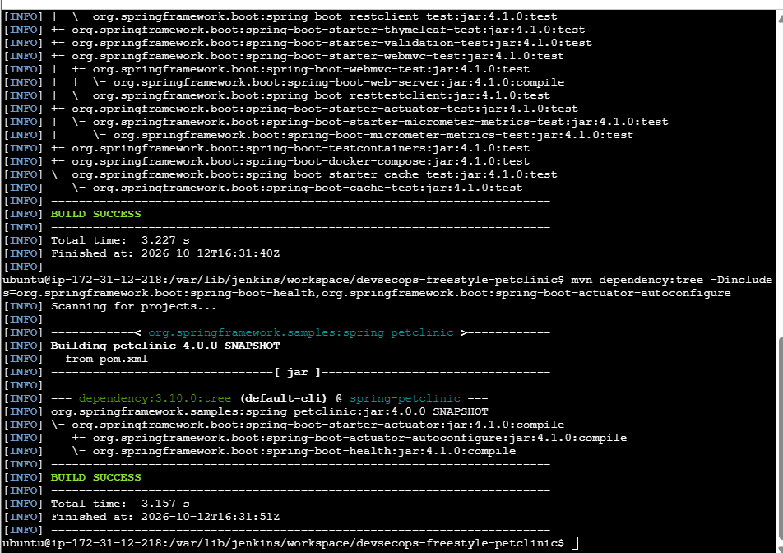
Maven dependency tree confirms:
Dependency | Version | Result
spring-boot-actuator-autoconfigure | 4.1.0 | Present
spring-boot-health | 4.1.0 | Present
Other Spring Boot dependencies | 4.1.0 | Confirmed
For CVE-2026-40976, the report itself says that an application depending on spring-boot-health is not vulnerable under the stated conditions. Your application has this dependency.
For CVE-2026-40974 and CVE-2026-40971, the report identifies Cassandra and RabbitMQ SSL-related issues, and our earlier checks found no corresponding Cassandra or RabbitMQ libraries in the packaged application.
Current conclusion: These three findings appear likely to be false positives caused by Dependency-Check matching the application's version (4.0.0-SNAPSHOT) to a Spring Boot CPE. We should document the evidence and verify the vendor advisories before suppressing anything.
Step 19.18 — Check the Spring Boot vendor advisories
Open these official advisory pages in your browser:
- CVE-2026-40974 — Spring advisory
- CVE-2026-40971 — Spring advisory
- CVE-2026-40976 — Spring advisory
Check the Affected versions and Fixed versions sections for each CVE.
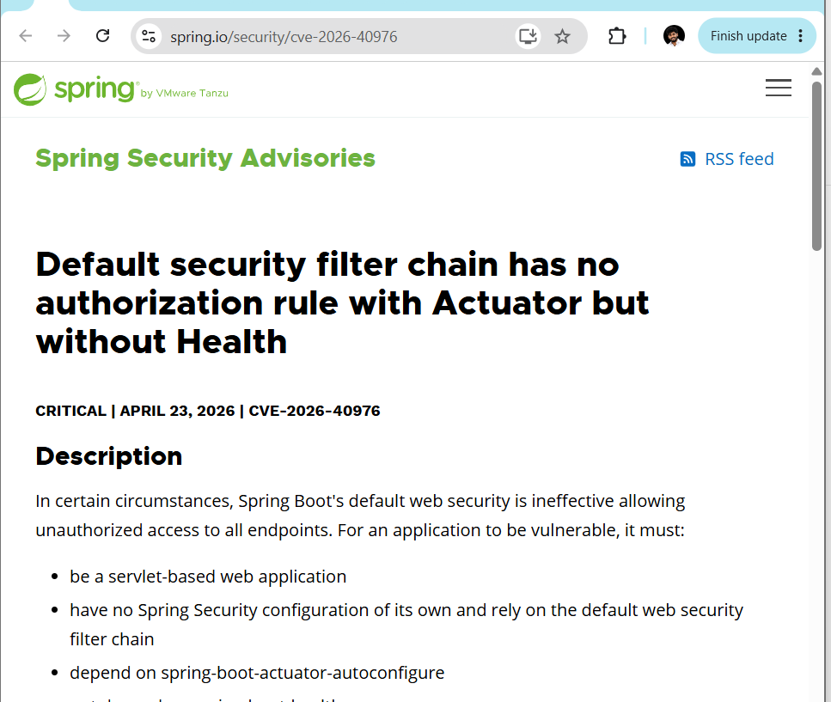
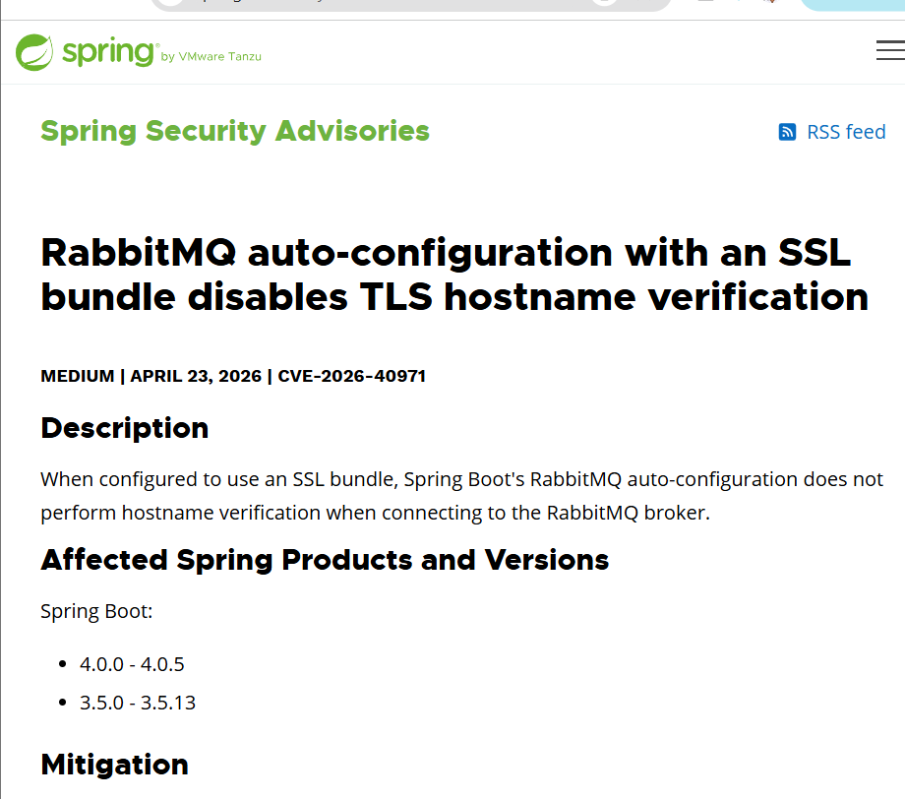
Official advisory verification
CVE | Affected versions shown in your screenshot | Your version
CVE-2026-40974 — Cassandra SSL hostname verification | 4.0.0–4.0.5; other older branches also listed | 4.1.0
CVE-2026-40971 — RabbitMQ SSL hostname verification | 4.0.0–4.0.5 and 3.5.0–3.5.13 | 4.1.0
CVE-2026-40976 — Default web security | 4.0.0–4.0.5, subject to the advisory's conditions | 4.1.0
Your packaged application uses Spring Boot 4.1.0, and we found no Cassandra or RabbitMQ libraries in the JAR. For CVE-2026-40976, your application also includes spring-boot-health, which the advisory identifies as a condition that rules out vulnerability.
Conclusion: All three findings appear to be false positives for this application based on the evidence we've gathered. We should retain that evidence rather than blindly dismissing every Critical finding.
Step 19.20 — One final check
Mama, run this command to confirm the exact application-level CPE match and confidence in the XML report:
grep -n -B 3 -A 5 'cpe:2.3:a:vmware:spring_boot:4.0.0:snapshot' \
/var/lib/jenkins/dependency-check-reports/dependency-check-report.xml
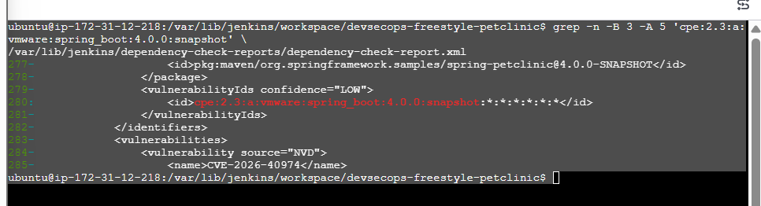
The report contains:
Package:
org.springframework.samples:spring-petclinic@4.0.0-SNAPSHOT

CPE match confidence:
LOW

Matched CPE:
cpe:2.3:a:vmware:spring_boot:4.0.0:snapshot
Final investigation summary
Check | Result
Spring Boot version in pom.xml and packaged JAR | 4.1.0
Cassandra/RabbitMQ libraries in packaged JAR | Not found
spring-boot-health dependency | Present, version 4.1.0
Official advisory version ranges reviewed | Yes
Application-level CPE match confidence | LOW
Assessment of the three findings | Likely false positives; evidence supports further validation
Is the first task completed?
Mama, the Jenkins build and OWASP Dependency-Check integration are completed. The build runs successfully and generates HTML/XML security reports.
The remaining security housekeeping is to document the false-positive evidence and decide whether a narrowly scoped suppression is appropriate. We should not suppress findings automatically just because the CPE confidence is low.
Next step — Step 19.21
Before modifying anything, let's preserve the current report. Run:
mkdir -p ~/devsecops-evidence

cp /var/lib/jenkins/dependency-check-reports/dependency-check-report.xml \
~/devsecops-evidence/

cp /var/lib/jenkins/dependency-check-reports/dependency-check-report.html \
~/devsecops-evidence/

ls -lh ~/devsecops-evidence/
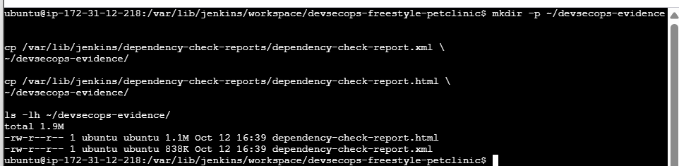
Dependency-Check reports are now backed up outside the Jenkins workspace.
- dependency-check-report.html — 1.1 MB
- dependency-check-report.xml — 838 KB
- Backup directory: ~/devsecops-evidence/
Step 19.22 — Record the investigation evidence
Let's create a short README documenting what we verified, so you can explain the findings during an interview or project review.
Run this command:
cat > ~/devsecops-evidence/README.txt <<'EOF'
DevSecOps - OWASP Dependency-Check Investigation
Date: 2026-10-12
Application: Spring PetClinic
Application version: 4.0.0-SNAPSHOT
Spring Boot version: 4.1.0

Evidence:
1. Original Dependency-Check HTML and XML reports backed up.
2. Packaged JAR manifest confirms Spring-Boot-Version: 4.1.0.
3. Maven dependency tree confirms Spring Boot dependencies use 4.1.0.
4. Cassandra and RabbitMQ libraries were not found in the packaged JAR.
5. spring-boot-health 4.1.0 is present.
6. Dependency-Check associated the application artifact with a Spring Boot 4.0.0-SNAPSHOT CPE at LOW confidence.
7. Official Spring advisories were reviewed for CVE-2026-40974,
CVE-2026-40971, and CVE-2026-40976.

Assessment:
The three findings appear to be false positives for this application,
based on the available evidence. This assessment should be validated
before any suppression is introduced. Do not treat the absence of
Cassandra/RabbitMQ libraries or low CPE confidence alone as proof.

No CVE suppression has been applied.
EOF

cat ~/devsecops-evidence/README.txt
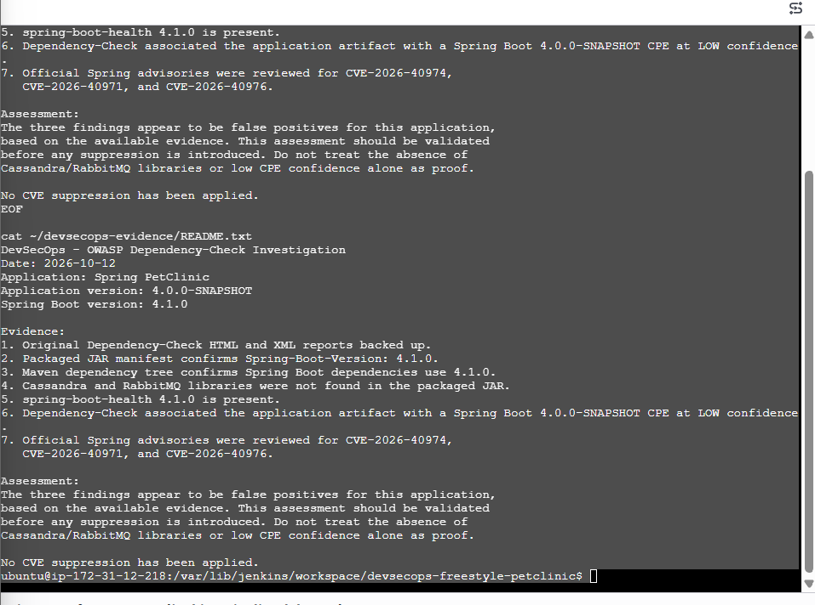
Step 19.23 — Verify the backup files
Run this command on your Ubuntu server:
ls -lh ~/devsecops-evidence/
Then run:
sha256sum \
~/devsecops-evidence/dependency-check-report.html \
~/devsecops-evidence/dependency-check-report.xml \
~/devsecops-evidence/README.txt
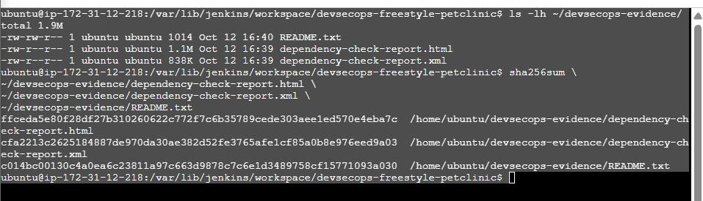
All three evidence files exist, and you've generated their SHA-256 checksums. These checksums can help verify whether the files change later.
Step 19.24 — Verify the checksums
Now let's verify the files against the checksums you just generated.
Run this command:
cd ~/devsecops-evidence

sha256sum README.txt dependency-check-report.html dependency-check-report.xml \
> SHA256SUMS.txt

sha256sum -c SHA256SUMS.txt
Expected output:
README.txt: OK
dependency-check-report.html: OK
dependency-check-report.xml: OK
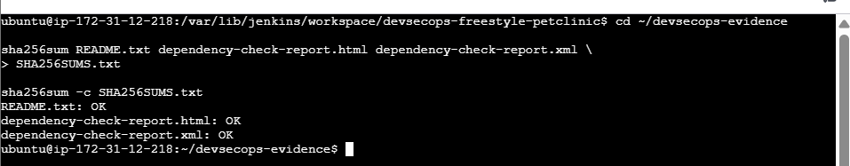
This means the files match the checksums recorded in SHA256SUMS.txt at the time of verification.

Challenge 2 — Declarative Pipeline:
Implement the same DevSecOps workflow using a Jenkinsfile, including security scanning with OWASP Dependency-Check and Trivy where compatible, plus build and test reporting.
Step 1 — Verify the existing Jenkins setup
http://13.233.3.4:8081
Before creating the Pipeline job, run these commands in your existing Ubuntu terminal:

java -version
mvn -version
git --version
docker --version
trivy --version
Some commands may report that Docker or Trivy is not installed. That's okay—we'll verify the output before deciding what to do.
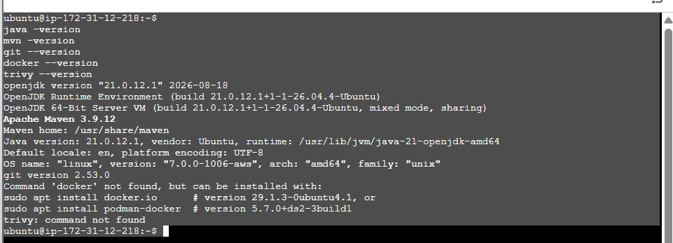
Step 2 — Check Jenkins Pipeline support
Let's verify the Pipeline plugin before creating the new job.
- Open Jenkins: http://13.233.3.4:8081
- Click Manage Jenkins.
- Open Plugins → Installed plugins.
- Search for Pipeline.
- Confirm that the Pipeline plugin is installed.
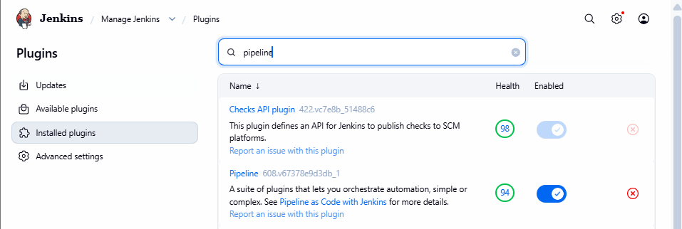
Step 3 — Create the Jenkins Pipeline job
- Open Jenkins Dashboard.
- Click New Item.
- Enter this name:
devsecops-pipeline-petclinic
- Select Pipeline — not Freestyle project.
- Click OK.
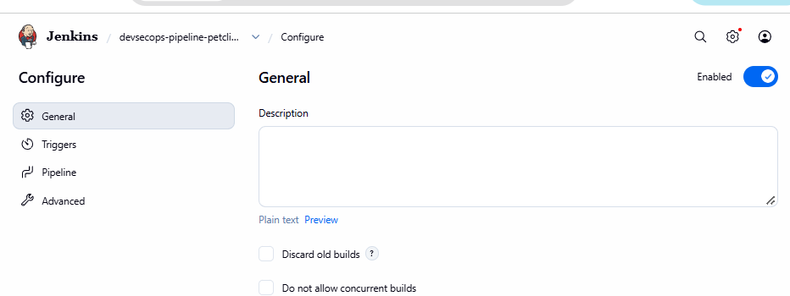
Step 4 — Configure the Pipeline job
On the page shown in your screenshot:
1. In General → Description, enter:
Challenge 2 - Declarative DevSecOps Pipeline for Spring PetClinic
- Leave the other General settings at their defaults for now.
- Click Pipeline in the left-side menu.
You should see fields such as Definition, Script, and possibly Script Path.
Step 5 — Configure the Pipeline definition
Set the following:
- Definition: Pipeline script
- Script: Leave it empty for now.
Don't click Save or Build Now yet.
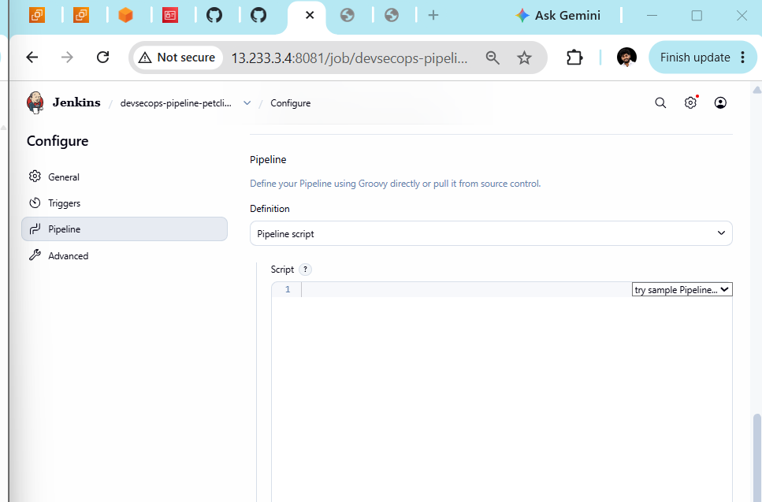
Step 6 — Enter the Declarative Jenkinsfile
Keep Definition = Pipeline script selected.
Click inside the large Script box and paste this initial Jenkinsfile. We'll start with checkout and Maven build/test, then add the security scans after confirming the first build works.

pipeline {
agent any

stages {
stage('Checkout') {
steps {
git branch: 'main',
url: 'https://github.com/betawins/spring-petclinic.git'
}
}

stage('Verify Tools') {
steps {
sh '''
echo "===== Java Version ====="
java -version

echo "===== Maven Version ====="
mvn -version

echo "===== Git Version ====="
git --version
'''
}
}

stage('Build and Test') {
steps {
sh 'mvn clean verify'
}
post {
always {
junit testResults: '**/target/surefire-reports/*.xml',
allowEmptyResults: true
}
}
}
}
}
Important, mama: This is the initial pipeline only; it does not yet include Dependency-Check or Trivy. It assumes the repository's default branch is main. If Jenkins reports that the branch does not exist, we'll verify the repository branch before changing anything.
Step 7 — Save the job
- Scroll to the bottom of the configuration page.
- Click Save.
- Return to the devsecops-pipeline-petclinic job page.
- Click Build Now.
- Open the new build number → Console Output.
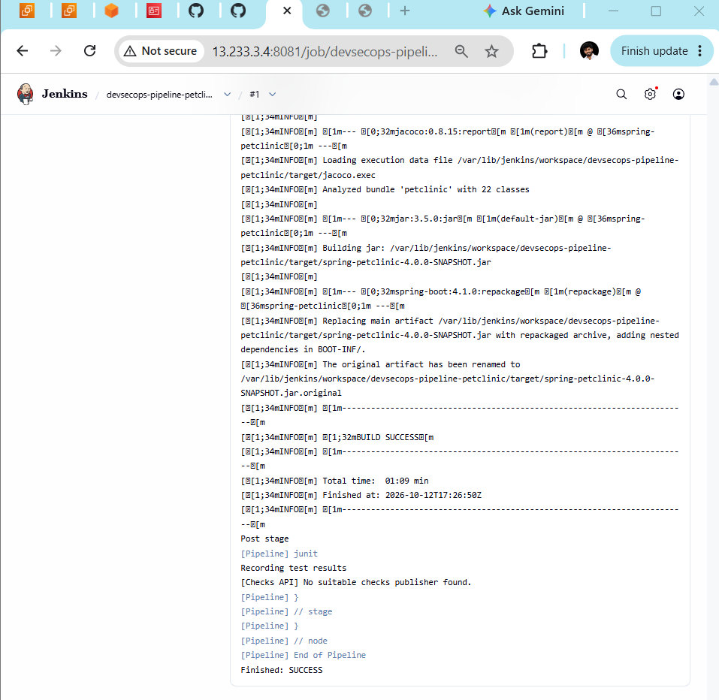
Step 8 — Add OWASP Dependency-Check to the Pipeline
Before editing the Jenkinsfile, let's verify the exact Dependency-Check command-line tool path and available reports on your server. This helps us reuse your existing setup instead of installing another scanner.
Run these commands in your Ubuntu terminal:

echo "===== Dependency-Check executable ====="
command -v dependency-check || true

echo "===== Dependency-Check report directory ====="
ls -lh /var/lib/jenkins/dependency-check-reports/

echo "===== Jenkins Dependency-Check tool configuration ====="
sudo ls -la /var/lib/jenkins/tools/ 2>/dev/null
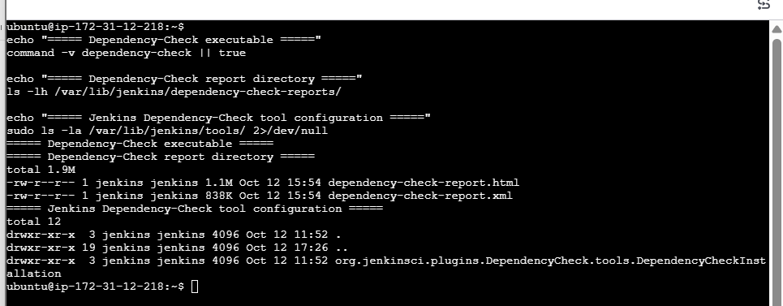
Step 9 — Locate the Dependency-Check scanner
Run this command in your Ubuntu terminal:

echo "===== Locate Dependency-Check files ====="
sudo find /var/lib/jenkins/tools/org.jenkinsci.plugins.DependencyCheck.tools.DependencyCheckInstallation \
-maxdepth 5 -type f \( -name dependency-check.sh -o -name dependency-check.bat \) \
-print 2>/dev/null
Then run:

echo "===== Check Jenkins Dependency-Check configuration ====="
sudo find /var/lib/jenkins/tools/org.jenkinsci.plugins.DependencyCheck.tools.DependencyCheckInstallation \
-maxdepth 3 -type d -print 2>/dev/null
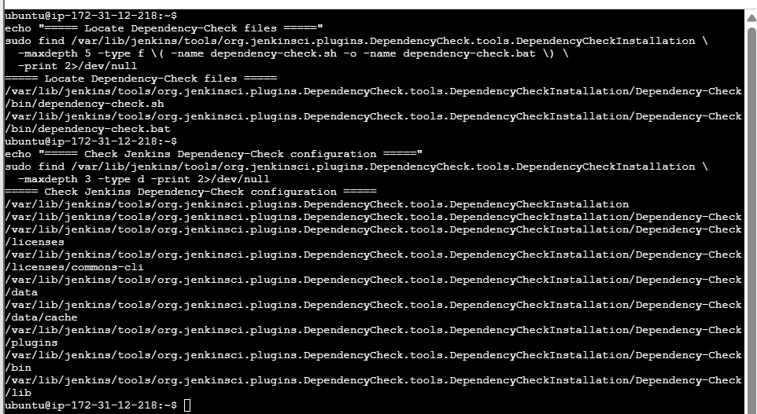
Step 10 — Add the NVD API key to Jenkins Credentials
First, let's confirm whether you already completed this step during Challenge 1.
- Open Jenkins: http://13.233.3.4:8081
- Click Manage Jenkins.
- Open Credentials.
- Select System → Global credentials (unrestricted), if that store is available.
- Look for a credential with ID nvd-api-key.
If nvd-api-key already exists: don't create another one. We'll reuse it for Challenge 2.
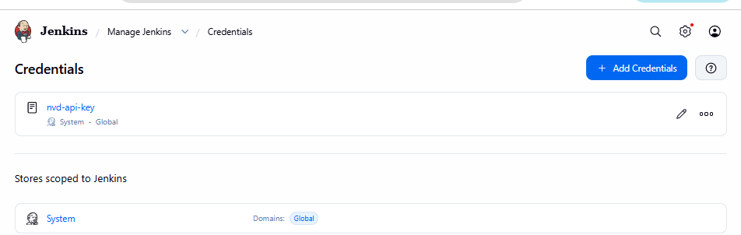
Step 11: Prepare the Dependency-Check stage
We already located the scanner at:
/var/lib/jenkins/tools/org.jenkinsci.plugins.DependencyCheck.tools.DependencyCheckInstallation/Dependency-Check/bin/dependency-check.sh
Before editing your successful Pipeline, let's confirm the exact credential type and whether the scanner can run.
Please do this:
- In Jenkins, click the nvd-api-key credential.
- Confirm its Kind is Secret text. Do not reveal or copy the secret.
- Return to your Ubuntu terminal and run:

sudo -u jenkins test -x /var/lib/jenkins/tools/org.jenkinsci.plugins.DependencyCheck.tools.DependencyCheckInstallation/Dependency-Check/bin/dependency-check.sh \
&& echo "Dependency-Check executable is available" \
|| echo "Dependency-Check executable is not executable"

sudo -u jenkins /var/lib/jenkins/tools/org.jenkinsci.plugins.DependencyCheck.tools.DependencyC
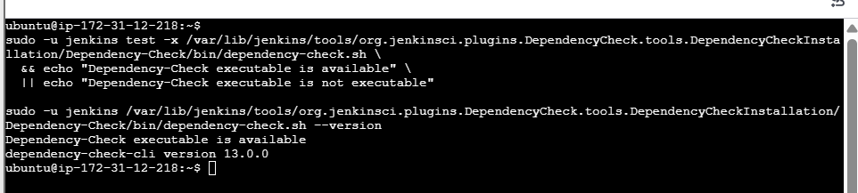
Step 12: Add Dependency-Check to the Declarative Pipeline
We'll update the existing devsecops-pipeline-petclinic Jenkinsfile. First, open the job → Configure → Pipeline → Script.
Replace the current Jenkinsfile with the following version. It preserves the successful checkout and Maven build, adds the Dependency-Check scan using your existing nvd-api-key credential, and archives the reports.

pipeline {
agent any

stages {
stage('Checkout') {
steps {
git branch: 'main',
url: 'https://github.com/betawins/spring-petclinic.git'
}
}

stage('Verify Tools') {
steps {
sh '''
java -version
mvn -version
git --version
'''
}
}

stage('Build and Test') {
steps {
sh 'mvn clean verify'
}
post {
always {
junit testResults: '**/target/surefire-reports/*.xml',
allowEmptyResults: true
}
}
}

stage('OWASP Dependency-Check') {
steps {
withCredentials([
string(credentialsId: 'nvd-api-key',
variable: 'NVD_API_KEY')
]) {
sh '''
set +x
SCANNER="/var/lib/jenkins/tools/org.jenkinsci.plugins.DependencyCheck.tools.DependencyCheckInstallation/Dependency-Check/bin/dependency-check.sh"

mkdir -p dependency-check-report

"$SCANNER" \
--scan . \
--format HTML \
--format XML \
--out dependency-check-report \
--nvdApiKey "$NVD_API_KEY"
'''
}
}
}
}

post {
always {
archiveArtifacts artifacts: 'dependency-check-report/**',
allowEmptyArchive: true
}
}
}
Before saving,
- Confirm the credential ID is exactly nvd-api-key.
- Keep the scanner path unchanged.
- Click Save, then Build Now.
- Open the new build's Console Output.
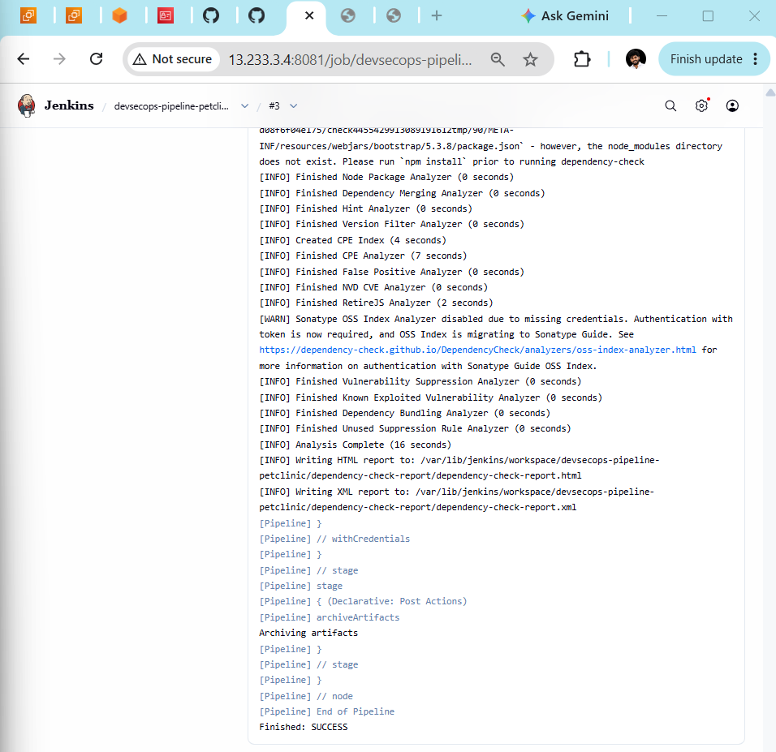
Step 13 — Verify the published reports
Mama, let's confirm that the reports are accessible from the Jenkins job.
- Open the devsecops-pipeline-petclinic job page.
- Click build #3.
- Look for Build Artifacts.
- Open dependency-check-report/.
- Confirm that these two files are present:
  - dependency-check-report.html
  - dependency-check-report.xml
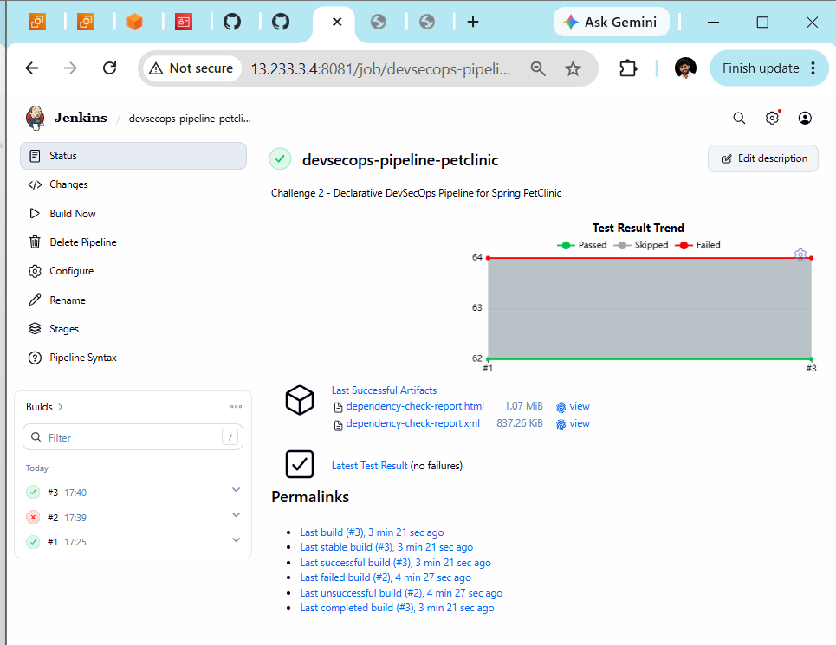
Step 14 — Review the security report
Let's review the generated report before moving to the next security tool.
- On this page, click dependency-check-report.html under Last Successful Artifacts.
- Review the Summary section.
- Check the vulnerability counts for Critical, High, Medium and Low.
- Don't suppress any CVEs or change the project dependencies yet.
